DB2 V105安装配置指南
目录
1 简介 1
1.1 目的 1
1.2 范围 2
1.3 术语定义、符号和缩略语 2
1.4 相关文档 2
2 规划 2
2.1 安装范围说明 2
2.2 架构说明 3
2.2.1 拓扑架构 3
2.3 安装介质 3
3 安装 3
3.1 安装前检查 3
3.1.1 Aix安装要求 3
3.1.2 磁盘要求 4
3.1.3 执行检查 4
3.2 准备安装介质 4
3.3 图形化安装 4
3.4 命令行安装 15
3.5 验证 22
3.6 注册 22
4 配置 23
4.1 HADR 23
4.1.1 配置HADR 23
4.1.2 HADR多备库 26
4.2 DPF 28
4.2.1 环境设置 28
4.2.2 配置DPF 29

简介

目的
本文目的在于描述DB2v10安装配置指南。

范围
在内容上仅限AIX平台DB2v10.5部署。

术语定义、符号和缩略语

缩写 | 全称 | 描述
BLU Acceleration | BLU加速 | BLU Acceleration整合了大幅改善分析能力和简化管理的一系列技术，能够将报告生成和数据分析速度提高25倍。
HADR | High Availability Disaster Recovery | 是数据库级别的高可用性数据复制灾难恢复机制
DPF | Database Partition Feature | 数据库分区特性，适合于统计类和分析的应用
pureScale |  | DB2 pureScale 是一种新特性，主要针对在线事务处理（online transaction processing，OLTP）向外扩展（scale-out）集群，提供最高级别的分布式可用性和可伸缩性。

相关文档

规划

安装范围说明
包括
- DB2v10.5的安装
- 配置HADR
- 配置DPF

不包括
- AIX的安装及补丁的安装等系统相关问题
- DB2v10.5数据库的创建等业务数据相关问题

架构说明

拓扑架构

备注：

安装介质
- DB2v10.5安装介质
介质名称 | 描述
v10.5_Aix64_server.tar.gz | DB2 v10.5 for AIX64安装介质

安装

安装前检查

Aix安装要求
启用purescale特性的具体安装要求见purescalue文档。
操作系统 | 硬件
AIX V6.1  需要 64 位 AIX 内核  AIX 6.1 技术级别 (TL) 7 和 Service Pack (SP) 6  最低 C++ 运行时级别需要 xlC.rte 12.1.0.1 和 xlC AIX rte 12.1.0.1（或更高版本）文件集。 | 64 位公共硬件参考平台 (CHRP) 体系结构。POWER5,POWER6®, POWER7® 和 POWER7+™支持DB2 v10.5。  启用BLU加速特性，推荐用POWER7。  所有能运行受支持的 AIX 操作系统的处理器。
AIX V7.1
需要 64 位 AIX 内核
AIX 7.1 技术级别 (TL) 1和 Service Pack (SP) 6
最低 C++ 运行时级别需要 xlC.rte 12.1.0.1 和 xlC AIX rte 12.1.0.1（或更高版本）文件集。

磁盘要求
目录名 | 最小空余空间要求
/ | 5G+
/opt | 5G+
/home | 5G+
/tmp | 2G+
/var | 512M+

执行检查
db2prereqcheck -v 10.5.0.0
./db2prereqcheck -v 10.5.0.0

准备安装介质
1）将db2v10.5安装介质上传到<MEDIA>/aix/目录，并在该目录解压缩

备注：
1：为保证各个安装介质中文件不会互相冲突，此处要求针对每个介质文件，分目录单独存放解压缩内容，且根据介质文件名中，去除后缀及数字前缀后的内容做为新建的目录名。

2：常用解压缩命令说明：
tar –vxf /root/xx.tar(将/root/xx.tar.gz格式文件解压缩到当前目录)：
gunzip *.tar.gz ：将*.tar.gz 解压缩为*.tar;
jar –vxf *.zip将zip文件解压缩到当前目录；

3：解压缩用户与安装用户必须是同一个用户，否则安装过程会出现问题。

图形化安装
1) 启动安装界面
启动xmanager，以root/xxxx登录，切换目录到<MEDIA>/server/中对应v10.5_linuxx64_server.tar.gz介质的解压缩目录，并执行如下命令：./db2setup，启动安装界面：
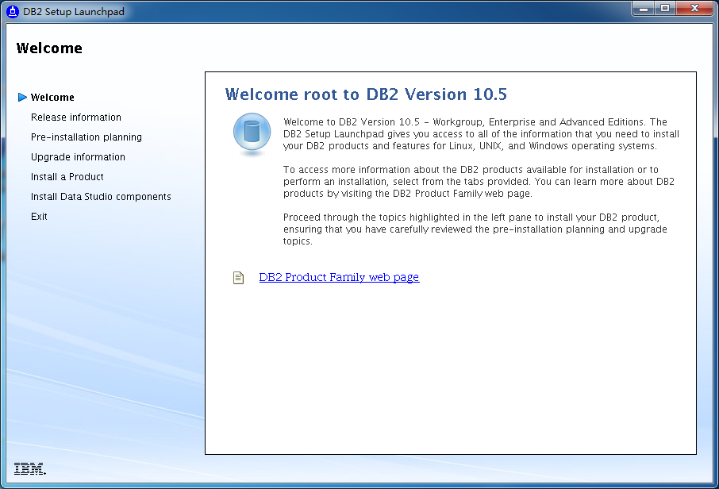

2）安装DB2：
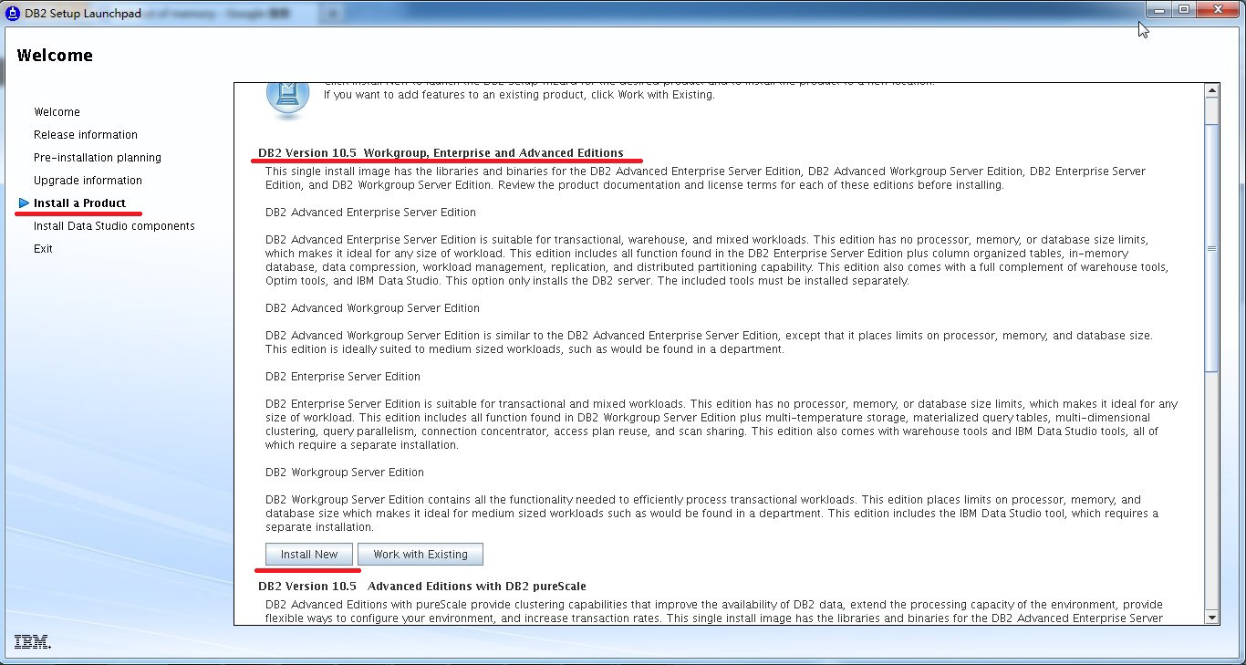
- 安装DB2

1. 在左侧菜单中选择“Install a Product”
2. 选择“Install New，然后按照系统默认选择进行WAS的安装。
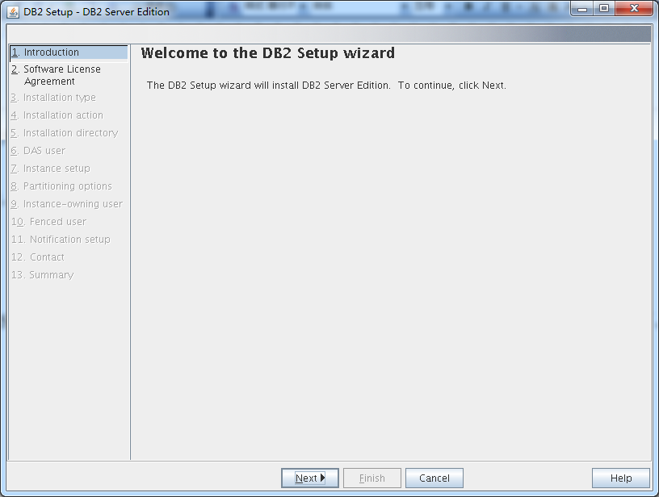
选择“Next”
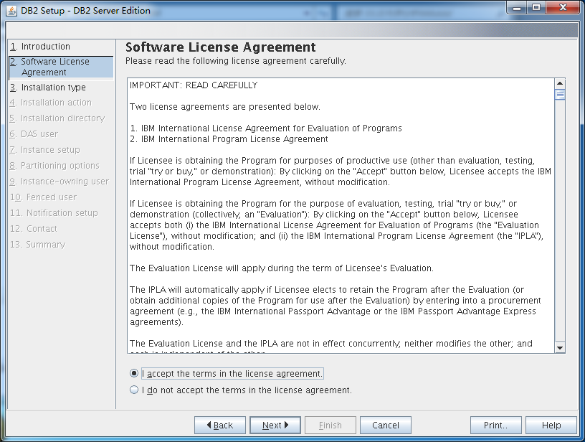
选择接受“Software License Agreement”，选择“Next”
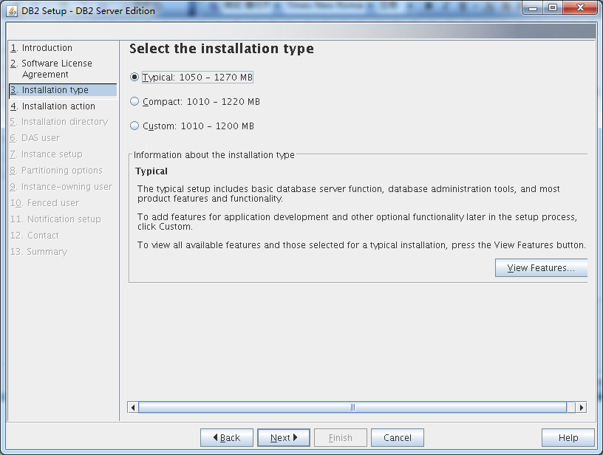
选中“Typical”安装类型，选择“Next”
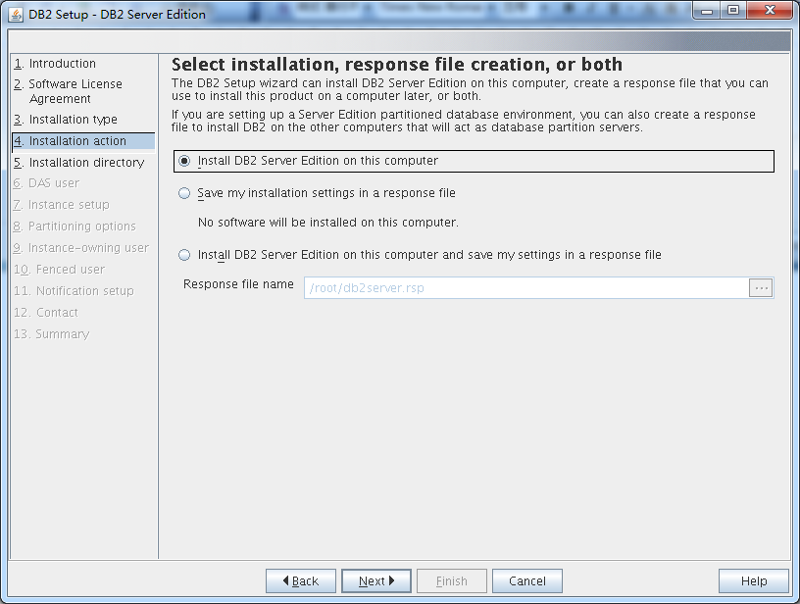
选中“Install DB2 Server Edition on this computer”，选择“Next”
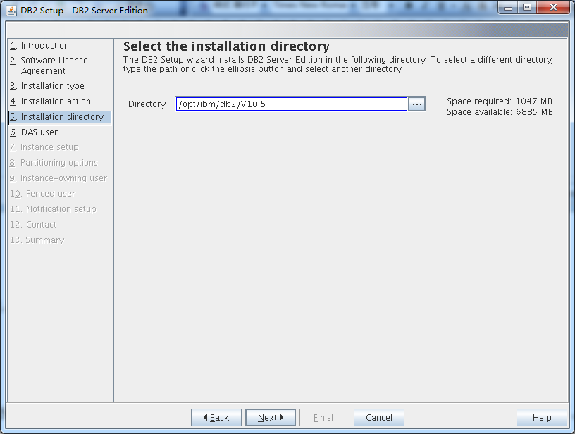
默认安装路径“/opt/ibm/db2/V10.5”，选择“Next”
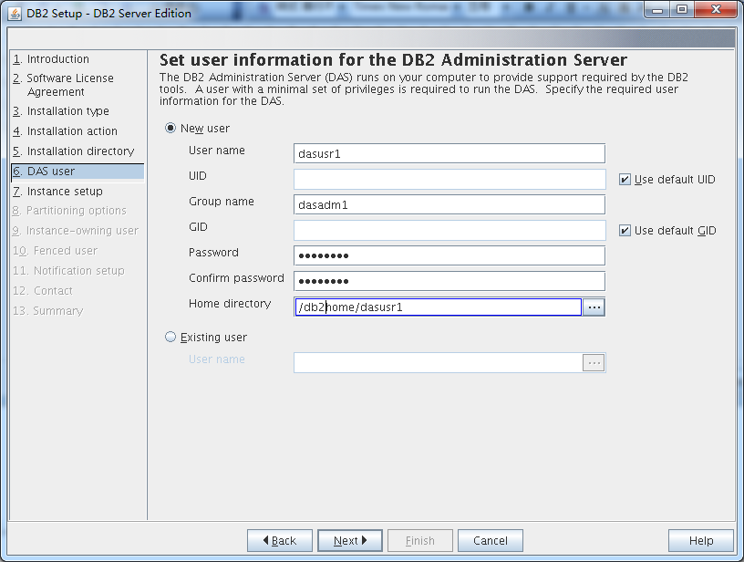
选中DAS用户模式“New user”以及用户信息，选择“Next”
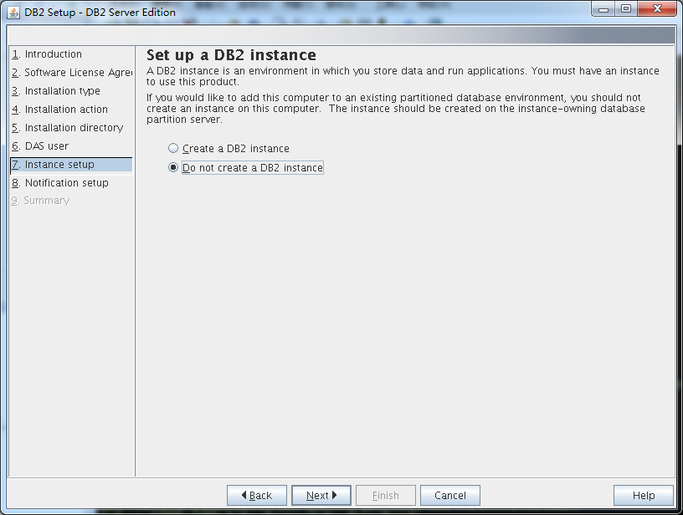
选中“Do not create a DB2 instance”，选择“Next”
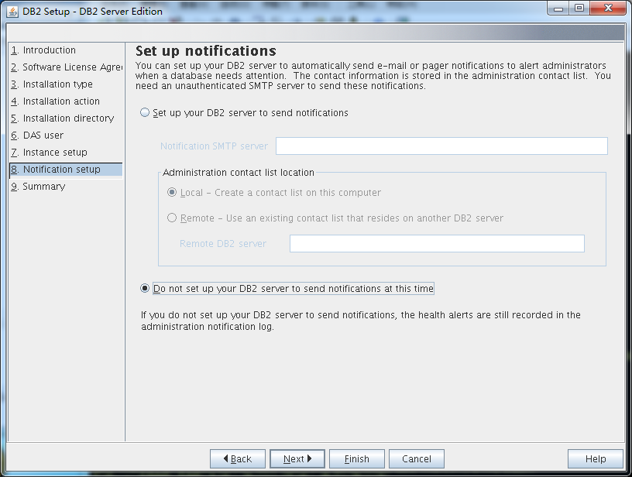
选中“Do not set up your DB2 server to send notifications at this time”，选择“Next”
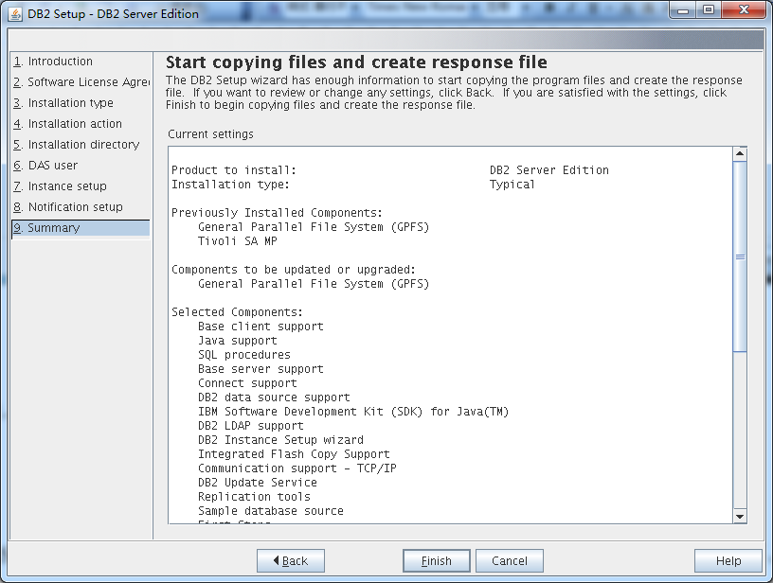
查看设置总结，确认后选择“Finish”

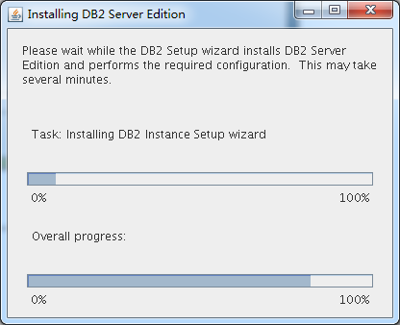
注意，此处DB2安装需要大约15－30分钟时间；

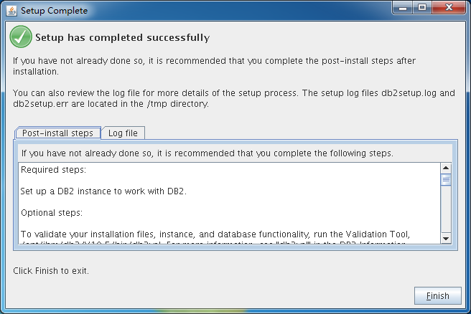
DB2安装成功。

命令行安装
交互模式
suse01:/db2bak/db2inst/db2v105/server # ./db2_install
DBI1324W Support of the db2_install command is deprecated. For
more information, see the DB2 Information Center.

Default directory for installation of products - /opt/ibm/db2/V10.5

***********************************************************
Install into default directory (/opt/ibm/db2/V10.5) ? [yes/no]
yes

Specify one of the following keywords to install DB2 products.

SERVER
CONSV
EXP
CLIENT
RTCL

Enter "help" to redisplay product names.

Enter "quit" to exit.

***********************************************************
server
***********************************************************
Do you want to install the DB2 pureScale Feature? [yes/no]
no
DB2 installation is being initialized.

Total number of tasks to be performed: 48
Total estimated time for all tasks to be performed: 1591 second(s)

Task #1 start
Description: Checking license agreement acceptance
Estimated time 1 second(s)
Task #1 end

Task #2 start
Description: Base Client Support for installation with root privileges
Estimated time 3 second(s)
Task #2 end

Task #3 start
Description: Product Messages - English
Estimated time 13 second(s)
Task #3 end

Task #4 start
Description: Base client support
Estimated time 293 second(s)
Task #4 end

Task #5 start
Description: Java Runtime Support
Estimated time 155 second(s)
Task #5 end

Task #6 start
Description: Java Help (HTML) - English
Estimated time 7 second(s)
Task #6 end

Task #7 start
Description: Base server support for installation with root privileges
Estimated time 7 second(s)
Task #7 end

Task #8 start
Description: Global Secure ToolKit
Estimated time 59 second(s)
Task #8 end

Task #9 start
Description: Java support
Estimated time 12 second(s)
Task #9 end

Task #10 start
Description: SQL procedures
Estimated time 3 second(s)
Task #10 end

Task #11 start
Description: ICU Utilities
Estimated time 35 second(s)
Task #11 end

Task #12 start
Description: Java Common files
Estimated time 18 second(s)
Task #12 end

Task #13 start
Description: Base server support
Estimated time 459 second(s)
Task #13 end

Task #14 start
Description: Control Center Help (HTML) - English
Estimated time 13 second(s)
Task #14 end

Task #15 start
Description: Connect support
Estimated time 3 second(s)
Task #15 end

Task #16 start
Description: Relational wrappers common
Estimated time 3 second(s)
Task #16 end

Task #17 start
Description: DB2 data source support
Estimated time 6 second(s)
Task #17 end

Task #18 start
Description: Spatial Extender server support
Estimated time 19 second(s)
Task #18 end

Task #19 start
Description: IBM Software Development Kit (SDK) for Java(TM)
Estimated time 48 second(s)
Task #19 end

Task #20 start
Description: DB2 LDAP support
Estimated time 4 second(s)
Task #20 end

Task #21 start
Description: DB2 Instance Setup wizard
Estimated time 20 second(s)
Task #21 end

Task #22 start
Description: Integrated Flash Copy Support
Estimated time 3 second(s)
Task #22 end

Task #23 start
Description: Spatial Extender client
Estimated time 3 second(s)
Task #23 end

Task #24 start
Description: Communication support - TCP/IP
Estimated time 3 second(s)
Task #24 end

Task #25 start
Description: Base application development tools
Estimated time 35 second(s)
Task #25 end

Task #26 start
Description: DB2 Update Service
Estimated time 4 second(s)
Task #26 end

Task #27 start
Description: Parallel Extension
Estimated time 3 second(s)
Task #27 end

Task #28 start
Description: EnterpriseDB code
Estimated time 4 second(s)
Task #28 end

Task #29 start
Description: Replication tools
Estimated time 53 second(s)
Task #29 end

Task #30 start
Description: Sample database source
Estimated time 4 second(s)
Task #30 end

Task #31 start
Description: itlm
Estimated time 3 second(s)
Task #31 end

Task #32 start
Description: DB2 Text Search
Estimated time 119 second(s)
Task #32 end

Task #33 start
Description: Command Line Processor Plus
Estimated time 4 second(s)
Task #33 end

Task #34 start
Description: Informix data source support
Estimated time 4 second(s)
Task #34 end

Task #35 start
Description: Oracle data source support
Estimated time 4 second(s)
Task #35 end

Task #36 start
Description: First Steps
Estimated time 3 second(s)
Task #36 end

Task #37 start
Description: Product Signature for DB2 Enterprise Server Edition
Estimated time 6 second(s)
Task #37 end

Task #38 start
Description: Guardium Installation Manager Client
Estimated time 20 second(s)
Task #38 end

Task #39 start
Description: Setting DB2 library path
Estimated time 180 second(s)
Task #39 end

Task #40 start
Description: Installing or updating DB2 HA scripts for IBM Tivoli System Automation for Multiplatforms (Tivoli SA MP)
Estimated time 40 second(s)
Task #40 end

Task #41 start
Description: Compiling GPL
Estimated time 30 second(s)
Task #41 end

Task #42 start
Description: Executing control tasks
Estimated time 20 second(s)
Task #42 end

Task #43 start
Description: Updating global registry
Estimated time 20 second(s)
Task #43 end

Task #44 start
Description: Starting DB2 Fault Monitor
Estimated time 10 second(s)
Task #44 end

Task #45 start
Description: Updating the db2ls link
Estimated time 1 second(s)
Task #45 end

Task #46 start
Description: Registering DB2 licenses
Estimated time 5 second(s)
Task #46 end

Task #47 start
Description: Setting default global profile registry variables
Estimated time 1 second(s)
Task #47 end

Task #48 start
Description: Initializing instance list
Estimated time 5 second(s)
Task #48 end

Task #49 start
Description: Registering DB2 Update Service
Estimated time 30 second(s)
Task #49 end

Task #50 start
Description: Updating global profile registry
Estimated time 3 second(s)
Task #50 end

The execution completed successfully.

For more information see the DB2 installation log at
"/tmp/db2_install.log.37436".

或者指定模式
suse01:/db2bak/db2inst/db2v105/server # ./db2_install -p server -b /opt/ibm/db2/V10.5 -t /tmp/db2_install.trc -l /tmp/db2_install.log -n
DBI1324W Support of the db2_install command is deprecated. For
more information, see the DB2 Information Center.

The execution completed successfully.

For more information see the DB2 installation log at "/tmp/db2_install.log".

验证
验证安装文件：
suse01:~ # cd /opt/ibm/db2/V10.5/bin/
suse01:/opt/ibm/db2/V10.5/bin # ./db2val –a
DBI1379I The db2val command is running. This can take several minutes.
DBI1335I Installation file validation for the DB2 copy installed at
/opt/ibm/db2/V10.5 was successful.
DBI1343I The db2val command completed successfully. For details, see
the log file /tmp/db2val-130607_163813.log.

注册
./db2licm -a db2ese_c.lic

LIC1402I License added successfully.

LIC1426I This product is now licensed for use as outlined in your License Agreement. USE OF THE PRODUCT CONSTITUTES ACCEPTANCE OF THE TERMS OF THE IBM LICENSE AGREEMENT, LOCATED IN THE FOLLOWING DIRECTORY: "/opt/ibm/db2/V10.5/license/en_US.iso88591"

配置

HADR
DB2 高可用性灾难恢复 (HADR) 功能是一种数据库复制方法，为部分和完整站点故障提供了高可用性解决方案。HADR 通过将数据更改从源数据库（称为主要数据库）移动到一个或多个目标数据库（称为备用数据库），预防数据丢失。

配置HADR
环境
主机名 | HADR服务端口 | 实例 | 备注
suse01 | 55001 | db2inst1 | 主库
suse02 | 55002 | db2inst2 | 备库

- 配置TCP/IP
对于使用JDBC调用模式
no -o tcp_keepidle=12
no -o tcp_keepintvl=2
no -o tcp_keepcnt=10

对于非JDBC调用模式
db2set DB2TCP_CLIENT_KEEPALIVE_TIMEOUT=20

注：提供的值是建议值，请根据特定网络和服务器功能对这些设置进行微调

- 修改services
修改所有机器
vi /etc/services
DB2_HADR_1 55001/tcp
DB2_HADR_2 55002/tcp
DB2_HADR_3 55003/tcp

- 主库配置
修改主库HADR参数
db2 update db cfg for testdb using HADR_LOCAL_HOST suse01
db2 update db cfg for testdb using HADR_LOCAL_SVC DB2_HADR_1
db2 update db cfg for testdb using HADR_REMOTE_HOST suse02
db2 update db cfg for testdb using HADR_REMOTE_SVC DB2_HADR_2
db2 update db cfg for testdb using HADR_REMOTE_INST DB2INST2
db2 update db cfg for testdb using HADR_SYNCMODE NEARSYNC
db2 update db cfg for testdb using HADR_TIMEOUT 10
db2 update db cfg for testdb using HADR_PEER_WINDOW 120
db2inst1@suse01:~> db2 update db cfg for testdb using HADR_LOCAL_HOST suse01
DB20000I The UPDATE DATABASE CONFIGURATION command completed successfully.
db2inst1@suse01:~> db2 update db cfg for testdb using HADR_LOCAL_SVC DB2_HADR_1
DB20000I The UPDATE DATABASE CONFIGURATION command completed successfully.
db2inst1@suse01:~> db2 update db cfg for testdb using HADR_REMOTE_HOST suse02
DB20000I The UPDATE DATABASE CONFIGURATION command completed successfully.
db2inst1@suse01:~> db2 update db cfg for testdb using HADR_REMOTE_SVC DB2_HADR_2
DB20000I The UPDATE DATABASE CONFIGURATION command completed successfully.
db2inst1@suse01:~> db2 update db cfg for testdb using HADR_REMOTE_SVC DB2_HADR_2
DB20000I The UPDATE DATABASE CONFIGURATION command completed successfully.
db2inst1@suse01:~> db2 update db cfg for testdb using HADR_REMOTE_INST DB2INST2
DB20000I The UPDATE DATABASE CONFIGURATION command completed successfully.
db2inst1@suse01:~> db2 update db cfg for testdb using HADR_SYNCMODE NEARSYNC
DB20000I The UPDATE DATABASE CONFIGURATION command completed successfully.
db2inst1@suse01:~> db2 update db cfg for testdb using HADR_TIMEOUT 10
DB20000I The UPDATE DATABASE CONFIGURATION command completed successfully.
db2inst1@suse01:~> db2 update db cfg for testdb using HADR_PEER_WINDOW 120
DB20000I The UPDATE DATABASE CONFIGURATION command completed successfully.

配置索引记录，并取消自动执行崩溃恢复
db2inst1@suse01:~> db2 UPDATE DB CFG FOR testdb USING INDEXREC RESTART LOGINDEXBUILD ON AUTORESTART OFF
DB20000I The UPDATE DATABASE CONFIGURATION command completed successfully.

启用归档，建议选择共享归档。
db2inst1@suse01:~> db2 update db cfg for testdb using LOGARCHMETH1 "disk:/db2bak/archlogs"
DB20000I The UPDATE DATABASE CONFIGURATION command completed successfully.

主库脱机备份
db2inst1@suse01:~> db2 force applications all
DB20000I The FORCE APPLICATION command completed successfully.
DB21024I This command is asynchronous and may not be effective immediately.

db2inst1@suse01:~> db2 terminate
DB20000I The TERMINATE command completed successfully.
db2inst1@suse01:~> db2 deactivate db testdb
DB20000I The DEACTIVATE DATABASE command completed successfully.
db2inst1@suse01:~> db2 backup db testdb to /db2bak/ without prompting

Backup successful. The timestamp for this backup image is : 20130621114705

- 备库配置
恢复数据库
db2inst2@suse02:~> db2 restore db testdb from /db2bak taken at 20130621114705 on /db2home/db2inst2/testdb replace history file
DB20000I The RESTORE DATABASE command completed successfully.

修改备库HADR参数
db2 update db cfg for testdb using HADR_LOCAL_HOST suse02
db2 update db cfg for testdb using HADR_LOCAL_SVC DB2_HADR_2
db2 update db cfg for testdb using HADR_REMOTE_HOST suse01
db2 update db cfg for testdb using HADR_REMOTE_SVC DB2_HADR_1
db2 update db cfg for testdb using HADR_REMOTE_INST db2inst1
db2 update db cfg for testdb using HADR_SYNCMODE NEARSYNC
db2 update db cfg for testdb using HADR_TIMEOUT 10
db2 update db cfg for testdb using HADR_PEER_WINDOW 120
db2inst2@suse02:~> db2 update db cfg for testdb using HADR_LOCAL_SVC DB2_HADR_2
DB20000I The UPDATE DATABASE CONFIGURATION command completed successfully.
db2inst2@suse02:~> db2 update db cfg for testdb using HADR_REMOTE_HOST suse01
DB20000I The UPDATE DATABASE CONFIGURATION command completed successfully.
db2inst2@suse02:~> db2 update db cfg for testdb using HADR_REMOTE_SVC DB2_HADR_1
DB20000I The UPDATE DATABASE CONFIGURATION command completed successfully.
db2inst2@suse02:~> db2 update db cfg for testdb using HADR_REMOTE_INST db2inst1
DB20000I The UPDATE DATABASE CONFIGURATION command completed successfully.
db2inst2@suse02:~> db2 update db cfg for testdb using HADR_SYNCMODE NEARSYNC
DB20000I The UPDATE DATABASE CONFIGURATION command completed successfully.
db2inst2@suse02:~> db2 update db cfg for testdb using HADR_TIMEOUT 10
DB20000I The UPDATE DATABASE CONFIGURATION command completed successfully.
db2inst2@suse02:~> db2 update db cfg for testdb using HADR_PEER_WINDOW 120
DB20000I The UPDATE DATABASE CONFIGURATION command completed successfully.

- 启用HADR
在备库执行
db2inst2@suse02:~> db2 deactivate db testdb
DB20000I The DEACTIVATE DATABASE command completed successfully.
db2inst2@suse02:~> db2 start hadr on db testdb as standby
DB20000I The START HADR ON DATABASE command completed successfully.
在主库执行
db2inst1@suse01:/db2bak> db2 deactivate db testdb
DB20000I The DEACTIVATE DATABASE command completed successfully.
db2inst1@suse01:/db2bak> db2 start hadr on db testdb as primary
DB20000I The START HADR ON DATABASE command completed successfully.

HADR多备库
环境
主机名 | HADR服务端口 | 实例 | 备注
suse01 | 55001 | db2inst1 | 主库
suse02 | 55002 | db2inst2 | 主备
suse03 | 55003 | db2inst3 | 辅备

同4.1.1配置HADR的操作，再做以下配置：
- 配置主库
db2inst1@suse01:/db2bak> db2 update db cfg for testdb using HADR_TARGET_LIST 'suse02:55002|suse03:55003'
DB20000I The UPDATE DATABASE CONFIGURATION command completed successfully.

配置主备库
db2inst2@suse02:~> db2 update db cfg for testdb using HADR_TARGET_LIST 'suse01:55001|suse03:55003'
DB20000I The UPDATE DATABASE CONFIGURATION command completed successfully.

配置辅备库
db2inst3@suse03:~>db2 update db cfg for testdb using HADR_TARGET_LIST 'suse01:55001|suse02:55002'
DB20000I The UPDATE DATABASE CONFIGURATION command completed successfully.
db2inst3@suse03:~>db2 update db cfg for testdb using HADR_LOCAL_HOST suse03
DB20000I The UPDATE DATABASE CONFIGURATION command completed successfully.
db2inst3@suse03:~>db2 update db cfg for testdb using HADR_LOCAL_SVC DB2_HADR_3
DB20000I The UPDATE DATABASE CONFIGURATION command completed successfully.
db2inst3@suse03:~>db2 update db cfg for testdb using HADR_REMOTE_HOST suse01
DB20000I The UPDATE DATABASE CONFIGURATION command completed successfully.
db2inst3@suse03:~>db2 update db cfg for testdb using HADR_REMOTE_SVC DB2_HADR_1
DB20000I The UPDATE DATABASE CONFIGURATION command completed successfully.
db2inst3@suse03:~>db2 update db cfg for testdb using HADR_REMOTE_INST db2inst1
DB20000I The UPDATE DATABASE CONFIGURATION command completed successfully.
db2inst3@suse03:~>db2 update db cfg for testdb using HADR_SYNCMODE SUPERASYNC
DB20000I The UPDATE DATABASE CONFIGURATION command completed successfully.
db2inst3@suse03:~>db2 update db cfg for testdb using HADR_TIMEOUT 3
DB20000I The UPDATE DATABASE CONFIGURATION command completed successfully.
db2inst3@suse03:~>db2 update db cfg for testdb using HADR_PEER_WINDOW 120
DB20000I The UPDATE DATABASE CONFIGURATION command completed successfully.

DPF

环境设置
将 AIX maxuproc（每个用户的最大进程数）设备属性设置为 4096：
chdev -l sys0 -a maxuproc='4096'

修改TCP参数，以下是最小值，如果现有参数的值较高则不需要修改。
no -a | more
no -o thewall = 65536
no -o sb_max = 1310720
no -o rfc1323 = 1
no -o tcp_sendspace = 221184
no -o tcp_recvspace = 221184
no -o udp_sendspace = 65536
no -o udp_recvspace = 65536
no -o ipqmaxlen = 250
no -o somaxconn = 1024

在suse01上创建主文件系统 /db2home
smit jfs
/db2home

在suse01上nfs导出主文件系统 /db2home
smit nfs
/db2home
suse01,suse02,suse03

在其他机器上安装db2主文件系统
smit nfs
/db2home
/etc/filesystems all yes
read and wirte
head install

在所有机器上创建相同用户和组
mkgroup id=999 db2iadm1
mkgroup id=998 db2fadm1
mkgroup id=997 dasadm1

mkuser id=1004 pgrp=db2iadm1 groups=db2iadm1 home=/db2home/db2inst1 core=-1 data=491519 stack=32767 rss=-1 fsize=-1 db2inst1
mkuser id=1003 pgrp=db2fadm1 groups=db2fadm1 home=/db2home/db2fenc1 db2fenc1
mkuser id=1002 pgrp=dasadm1 groups=dasadm1 home=/home/dasusr1 dasusr1

配置DPF
在suse01创建实例
./db2icrt -a server -p 50000 -s ese -u db2fenc1 db2inst1

配置rsh
db2inst1@suse01:~> vi .rhosts
suse01 db2inst1
suse02 db2inst1
suse03 db2inst1

修改db2node.cfg
db2inst1@suse01:~/sqllib> vi db2nodes.cfg
0 suse01 0
1 suse01 1
2 suse02 0
3 suse02 1
4 suse03 0
5 suse03 1

